ALPHA PHI ALPHA FRATERNITY, INC.
Brother Matthew Coats
TZL Outstanding Brother of the Year
Competition Portfolio | November 2026
2025–2026 PROFESSIONAL ACCOMPLISHMENTS & COMMUNITY LEADERSHIP SUMMARY
Building Leaders.
Strengthening Families.
Empowering Communities.
Theta Zeta Lambda Chapter | Ann Arbor and Ypsilanti, Michigan

COMPETITION PORTFOLIO

Executive Leadership Profile
A record of program growth, community impact, organizational development, and sustainable service.
LEADERSHIP THEME
Building Leaders. Strengthening Families. Empowering Communities.

During the 2025–2026 program year, Brother Matthew M.M.W. Coats combined direct service with institution building. His leadership expanded youth mentoring, strengthened family support, advanced civic education, developed regional literacy partnerships, secured new resources, modernized public communications, and created governance systems designed to endure beyond a single year of service.
His work reflects a consistent leadership model: identify a community need, organize people and resources around a practical response, measure the result, and build the structure necessary for long-term sustainability. Rather than limiting his service to individual events, he created connected systems that increased the capacity of Theta Zeta Lambda Chapter and its community programs.

Impact at a Glance
$27,800+  RAISED FOR YOUTH, FAMILIES, AND COMMUNITY PROGRAMS | 337+  FAMILIES DIRECTLY IMPACTED
36 / 32  ESQUIRES REGISTERED / ACTIVE | 96%  ELIGIBLE ESQUIRE RETENTION
35 / 24  MENTORS TRAINED / ACTIVE ONE-TO-ONE MATCHES | 137,000  MEALS PACKED IN A HUNGER-RELIEF SERVICE SESSION
1,003 lb.  FOOD SORTED THROUGH FOOD GATHERERS | 10  MEMBERS ON THE NEW NONPROFIT BOARD

Leadership Distinction
Brother Coats distinguished himself by simultaneously leading established programs, launching new initiatives, building nonprofit infrastructure, expanding strategic partnerships, and creating a unified community-impact platform. The result was not only greater service in the present, but stronger systems for future leaders to sustain and expand.

EXECUTIVE LEADERSHIP & ORGANIZATIONAL DEVELOPMENT

Building Sustainable Impact
Founding and activating the TZL Community & Education Initiative.
Brother Coats led the creation and launch of the TZL Community & Education Initiative (CEI), a nonprofit umbrella organization supporting youth development, family assistance, civic engagement, and community service. He was appointed founding President and guided the organization from concept to operational readiness.

01 BOARD FORMATION AND GOVERNANCE
He recruited and developed a 10-member Board of Directors and established the framework required for responsible nonprofit leadership. The governance system included the following integrated components:
GOVERNANCE FOUNDATION | OPERATIONAL TOOLS
Constitution and Bylaws | Board orientation materials
Governance policies | Governance binders and templates
Board duties and role descriptions | Meeting agendas and reporting structures
Board acceptance documentation | Committee structures and charters
Conflict of Interest policy | Strategic planning processes
Confidentiality agreements | Financial transition roadmap

02 OPERATIONAL READINESS
Brother Coats developed the Board Activation and Financial Transition Plan to guide independent operations and long-term sustainability. He coordinated preparations involving banking, accounting, compliance, donor stewardship, fundraising systems, scholarship administration, and strategic planning. He also established meeting schedules, committee frameworks, recurring reporting expectations, and decision-making processes that positioned the Board to govern effectively from its first year.

03 COMMUNITY PARTNERSHIP LUNCHEON
To support future growth, he planned and launched the inaugural Community Partnership Luncheon. The event was designed to introduce donors, sponsors, civic leaders, educators, businesses, foundations, and strategic partners to the full CEI impact model while creating a foundation for sustained collaboration and resource development.
EXECUTIVE LEADERSHIP RESULT
A new organization was not simply announced; it was equipped with leadership, policies, financial systems, strategic processes, and a pathway to sustainability.

FUNDRAISING & RESOURCE DEVELOPMENT

Securing Resources & Building Partnerships
Turning relationships into measurable support for mission-driven work.
Brother Coats helped secure grants, sponsorships, donations, and fundraising proceeds that strengthened youth mentoring, family assistance, civic engagement, and nonprofit capacity. His approach paired compelling impact communication with disciplined stewardship and relationship building.

01 GRANT AND FUNDRAISING ACHIEVEMENTS
RESOURCE | AMOUNT / PURPOSE
Ann Arbor Area Community Foundation grant — November 2025 | $5,100 supporting youth leadership and mentoring
Ann Arbor Area Community Foundation grant — June 2026 | $7,500 supporting continued program growth
ELMP fundraising and support | More than $18,000 generated for youth programming
Caring & Sharing fundraising and support | More than $9,800 generated for family assistance and food security

02 DONOR AND COMMUNITY COMMUNICATIONS
He developed sponsorship packets, donor engagement materials, impact reports, community presentations, and outreach resources that clearly communicated program outcomes and future opportunities. These tools strengthened the organization's ability to present a consistent case for support across multiple audiences.

03 STRATEGIC PARTNERSHIP NETWORK
PARTNER | COLLABORATION FOCUS
Ann Arbor Area Community Foundation | Grant support and youth-development investment
Washtenaw Intermediate School District CTE | Career and technical education exposure
Food Gatherers | Food recovery, volunteer service, and year-round food access planning
Hope Clinic | Distribution of Family Essentials Hygiene Kits
YoungLives | Holiday family sponsorship and support
NorthRidge Church / Feed My Starving Children | Large-scale meal-packing service
NPHC D9 Literacy Project | Regional literacy planning and educational collaboration

RESOURCE DEVELOPMENT RESULT
The fundraising record demonstrates more than revenue generation; it reflects trust, credibility, effective communication, and the ability to align partners with meaningful community outcomes.

YOUTH LEADERSHIP & MENTORING

Building Leaders
Transforming the Esquire Leadership and Mentoring Program.
As Program Director for the Esquire Leadership and Mentoring Program (ELMP), Brother Coats strengthened participation, family engagement, mentor readiness, curriculum quality, and long-term leadership development. His work moved the program beyond annual activities toward a comprehensive youth-development system.

01 PROGRAM GROWTH AND OUTCOMES
- 26 of 27 eligible Esquires committed to return for the 2026–2027 program year.
- Enrollment reached the full capacity of 40 Esquires for 2026–2027.
- Five Legacy Esquires graduated, and three received scholarships from the TZL scholarship fund.
- Thirty-five parents and guardians remained actively engaged in the program.

02 CURRICULUM AND RECOGNITION INNOVATION
- Expanded the ELMP Information Packet from 12 pages to 24 pages, improving transparency and family communication.
- Created the Engagement & Positive Reinforcement System (EPRS) to measure academic performance, attendance and participation, leadership and conduct, college and career readiness, and personal growth and reflection.
- Established a recognition pathway featuring achievement levels, badges, jackets, and long-term leadership benchmarks.
- Created a Parent Outreach Team to strengthen communication, participation, and family support.
- Developed the Junior Esquire Curriculum to expand age-appropriate leadership opportunities for younger participants.
- Launched the History, Heritage, & Cultural Identity Series to provide structured cultural education and leadership discussion.
- Implemented the Etiquette and Project Alpha Initiative, emphasizing personal responsibility, healthy decision-making, life skills, and leadership conduct.

03 COLLEGE, CAREER, AND ACADEMIC READINESS
- Implemented the "Get to High School, Go to College" college-readiness initiative.
- Established a strategic partnership with WISD-CTE to expose Esquires to career and technical education pathways.
- Expanded programming in career exploration, résumé development, interview preparation, workforce readiness, and professional leadership.
- Ensured program participation across Alpha Phi Alpha Fraternity's national program areas of mentoring and education, community service, fundraising, and social development.

ELMP PROGRAM INNOVATION

Academic Support Infrastructure
The On-Demand Tutoring Support Network provides timely, flexible, and family-centered assistance.
Brother Coats designed an on-call tutoring model that connects Esquires with trained mentors when a specific academic concern arises. The system provides targeted support without requiring tutors to accept a standing weekly assignment.

01 TUTORING REQUEST AND MATCHING PROCESS
STEP | PROCESS
1. Need identified | A parent, guardian, or mentor recognizes a challenge involving coursework, test preparation, organization, or study skills.
2. Request submitted | The request identifies the Esquire, subject area, and observations that may help guide support.
3. Coordinator review | The Program Coordinator reviews the Academic Tutoring Support Form and available mentor resources.
4. Tutor matched | A tutor is selected according to subject expertise, preferred grade level, availability, and in-person or Zoom preference.
5. Family confirmation | The Esquire and tutor are connected only after the parent or guardian is informed and agrees with the support plan.
6. Targeted assistance | Sessions may be one-time or limited in duration and conclude when the identified academic concern has been addressed.

02 VOLUNTEER FLEXIBILITY AND PROGRAM SAFEGUARDS
- Tutors identify the subjects, grade levels, availability, and delivery formats they are comfortable supporting.
- Joining the network places a mentor on an on-call resource list and does not create an immediate tutoring obligation.
- Mentors may accept or decline individual requests according to their availability at the time of contact.
- Tutors are encouraged to complete Risk Management, Mentor Training, and the ELMP Academic Tutoring Support Form before serving.
- Parents and guardians remain informed throughout the process, preserving transparency and family oversight.
YOUTH LEADERSHIP RESULT
ELMP was not merely maintained. It was strengthened through measurable standards, expanded curriculum, family engagement, academic intervention, mentor development, and a clear pathway from participation to leadership.

COMMUNITY SERVICE & FAMILY SUPPORT

Strengthening Families
Expanding the Dr. Thomas A. Bass Caring & Sharing Program.
As Co-Director of the Dr. Thomas A. Bass Caring & Sharing Program, Brother Coats helped organize direct assistance for families, widows, and community partners while developing new systems for food access and year-round support.

01 DIRECT FAMILY ASSISTANCE
SERVICE INITIATIVE | OUTCOME
Thanksgiving outreach | 170 families served
Christmas outreach | 57 families served
Spring outreach | 40 families served
Widow visitation and recognition | 10 widows honored and supported
YoungLives partnership | Two families adopted during the Christmas season
Family Essentials Hygiene Kits | 40 kits assembled and delivered to Hope Clinic

02 FOOD SECURITY AND HUNGER RELIEF
Brother Coats coordinated Food Gatherers volunteer service that converted recovered food into approximately 836 meals for local households. He also participated in the Million Meals Project in partnership with NorthRidge Church and Feed My Starving Children, contributing to an international hunger-relief effort working toward one million meals for children.

03 COMMUNITY EXPANSION AND SYSTEMS DEVELOPMENT
He initiated planning with Food Gatherers to establish a year-round food distribution partnership using Ypsilanti Community Middle School as a community hub. The proposed operating model brought together school leadership, program volunteers, and Caring & Sharing personnel while integrating food access, Family Essentials support, Senior Connections, and recurring volunteer engagement.
He also developed expansion concepts for a Winter Attire and Toys for Tots Drive, Christmas Family Sponsorship Program, and Community CPR and AED Certification Initiative. Together, these efforts created a broader platform for meeting seasonal needs while building toward continuous community support.
FAMILY SUPPORT RESULT
The program combined immediate relief with forward-looking infrastructure, allowing service to address urgent needs today while preparing for more consistent support throughout the year.

CIVIC ENGAGEMENT & REGIONAL EDUCATION

Empowering Communities
Advancing civic education, literacy, and informed participation.

01 TZL EMPOWER
Brother Coats created and launched TZL Empower, a nonpartisan civic education initiative focused on voter education, civic participation, and community awareness. He developed the program mission and vision, educational resources, outreach strategy, website, and public communications.

Empower Civic Education Symposium
He planned the inaugural Empower Civic Education Symposium for September 2026 and coordinated outreach involving Ann Arbor Mayor Christopher Taylor, Ypsilanti Mayor Nicole Brown, State Representative Morgan Foreman, and State Representative Jimmy Wilson Jr. The educational forum was designed to address government structure, housing and affordability, public safety, workforce development, education, legislative issues, ballot understanding, and practical civic participation.

02 POWER OF NINE LITERACY — NATIONAL RECOGNITION
Brother Coats helped coordinate the NPHC of Ann Arbor's collaborative National Reading Month initiative, connecting Divine Nine members with elementary students through literacy, mentorship, and visible community service.
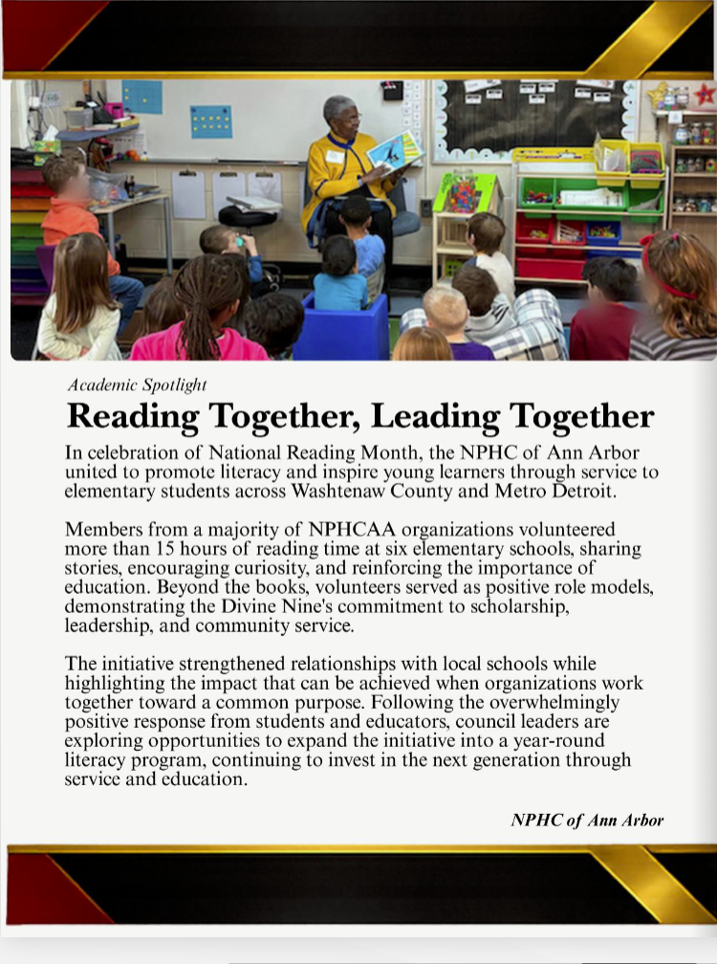  Featured in the inaugural national NPHC "Stronger Together" newsletter | NATIONAL NPHC RECOGNITION  Reading Together, Leading Together  The initiative was selected as the first featured highlight in the inaugural national NPHC "Stronger Together" newsletter. The recognition praised the initiative and coordination, supported by numerous Divine Nine readers, as a nationally distinguished community-service effort.  The strong community response created momentum to expand the effort into a year-round literacy program.
  6  elementary schools | 15+  volunteer reading hours
  REGIONAL  Washtenaw & Metro Detroit | DIVINE NINE  majority council participation

DIGITAL TRANSFORMATION

Modernizing Communication & Program Access
Creating a coordinated public-facing system for programs, families, donors, and partners.
Brother Coats recognized that strong programs require clear, accessible, and consistent communication. He modernized the ELMP and Caring & Sharing websites and designed new public platforms for TZL CEI and TZL Empower. This digital ecosystem gave each program a professional identity while connecting them under a unified community-impact structure.

01 INFORMATION AND OUTREACH SYSTEMS
- Created comprehensive information packets for ELMP, Caring & Sharing, TZL Empower, and TZL CEI.
- Developed marketing collateral, sponsorship presentations, donor packets, impact reports, and community outreach materials.
- Improved family-facing communication by organizing program expectations, participation pathways, and support resources in accessible formats.
- Established consistent messaging that presents youth development, family service, and civic education as connected pillars of one community mission.

02 UNIFIED PROGRAM ARCHITECTURE
PILLAR | PRIMARY PROGRAM | COMMUNITY PURPOSE
Building Leaders | Esquire Leadership and Mentoring Program | Youth leadership, mentoring, academic and career readiness
Strengthening Families | Dr. Thomas A. Bass Caring & Sharing Program | Food security, family assistance, and compassionate service
Empowering Communities | TZL Empower | Nonpartisan civic education and informed participation

This structure made the organization easier to understand, strengthened public credibility, and provided a clearer platform for partnership, fundraising, volunteer recruitment, and long-term growth.
COMMUNICATION RESULT
Professional communications became an operational asset—helping families participate, partners engage, donors understand impact, and programs present a consistent standard of excellence.

COMPETITION CASE STATEMENT

A Leadership Model Built for Sustainability
Problem → Action → Impact → Sustainability
The defining strength of Brother Coats's service is the connection between direct impact and durable infrastructure. Across every area of leadership, he moved beyond identifying problems and created systems that other leaders can continue to use.
AREA | PROBLEM | ACTION | IMPACT | SUSTAINABILITY
Youth development | Need for stronger engagement, recognition, and readiness | Expanded curriculum, EPRS, tutoring, mentoring pathways, and family outreach | Greater continuity, clearer standards, and a full next-year class | Reusable tools and leadership benchmarks
Family support | Seasonal food insecurity and household needs | Coordinated distributions, hygiene kits, volunteer partnerships, and hub planning | Broader direct assistance and hunger-relief service | Year-round food access model and expansion programs
Civic education | Need for accessible, nonpartisan community information | Created TZL Empower and planned a public education symposium | New platform for voter education and civic participation | Permanent website, resources, and partnership framework
Organizational capacity | Programs needed unified governance and financial infrastructure | Founded CEI, activated a Board, and built operating systems | Stronger accountability, fundraising readiness, and coordination | Independent nonprofit structure designed for continuity

01 QUALIFICATIONS DEMONSTRATED
- Executive leadership: built an organization, activated a Board, and established governance systems.
- Program innovation: created measurable youth-development, academic-support, and recognition frameworks.
- Community service: organized assistance for youth, families, widows, and households experiencing food insecurity.
- Resource development: secured grants, fundraising support, sponsors, and strategic partners.
- Collaboration: connected schools, foundations, nonprofits, churches, elected leaders, and regional organizations.
- Sustainability: converted successful activities into policies, tools, recurring systems, and long-term partnerships.
COMPETITIVE DISTINCTION
Brother Coats's record is distinguished not by the number of activities completed, but by the measurable impact achieved and the sustainable structures created for the chapter and community.

CLOSING STATEMENT

Why I Am Seeking This Recognition
A personal statement of service, stewardship, and lasting impact.
STATEMENT OF PURPOSE
During the 2025–2026 program year, I focused on creating systems that will continue to serve our community long after my term of service ends. Through mentoring young men, supporting families, expanding civic education, developing partnerships, and establishing the TZL Community & Education Initiative, I worked to build sustainable structures that strengthen our chapter's impact for years to come.

This portfolio represents a year of coordinated leadership across youth development, family support, civic engagement, literacy, fundraising, governance, and organizational development. Each accomplishment contributed to a larger objective: increasing the chapter's capacity to serve with excellence, accountability, compassion, and vision.
Brother Coats's leadership produced immediate community benefits while creating a foundation for future growth. Youth received stronger mentoring and academic support. Families received food, essential supplies, and compassionate care. Residents gained access to civic education. Community partners were invited into a more organized and sustainable service network. The chapter gained a nonprofit infrastructure capable of supporting its programs with greater consistency and credibility.
The lasting measure of this work is not simply what was completed in one program year. It is what can continue because the systems, partnerships, tools, and leadership structures are now in place.
BUILDING LEADERS. STRENGTHENING FAMILIES. EMPOWERING COMMUNITIES.
A record of service designed to create impact today and opportunity tomorrow.
Brother Matthew M.M.W. Coats
Theta Zeta Lambda Chapter | November 2026

